UTEROCARE AI
UML DIAGRAM DOCUMENTATION
Women’s Uterine Health Support System
1. Introduction
This document describes the five UML diagrams prepared for the proposed UteroCare AI system. The diagrams communicate the system’s users, structural design, interactions, workflow, and assessment lifecycle. They are intended to support the Software Requirements Specification (SRS) and implementation documentation.
2. Scope and modelling assumptions
UteroCare AI provides educational, preliminary health-assessment support for women’s uterine and gynaecological health.
Users may submit symptom information and menstrual-cycle details even when they do not have an ultrasound scan or medical report.
Uploaded documents are treated as supporting evidence; upload alone does not mean that a clinically validated image interpretation has been performed.
Assessment results must be labelled preliminary and must not be presented as a confirmed medical diagnosis.
The diagrams represent the proposed design. Before submission, align names, relationships, and workflows with the actual SRS and implemented application.

1. Use Case Diagram
This diagram identifies the main actors and the functions they can access within UteroCare AI. The Patient can register or log in, manage a profile, enter symptoms, record menstrual-cycle details, optionally upload a scan or medical report, view preliminary results and safety guidance, review assessment history, and find clinician resources. A Healthcare Professional may review flagged assessments, while an Administrator manages users and condition information. The system boundary encloses the functions provided by UteroCare AI.
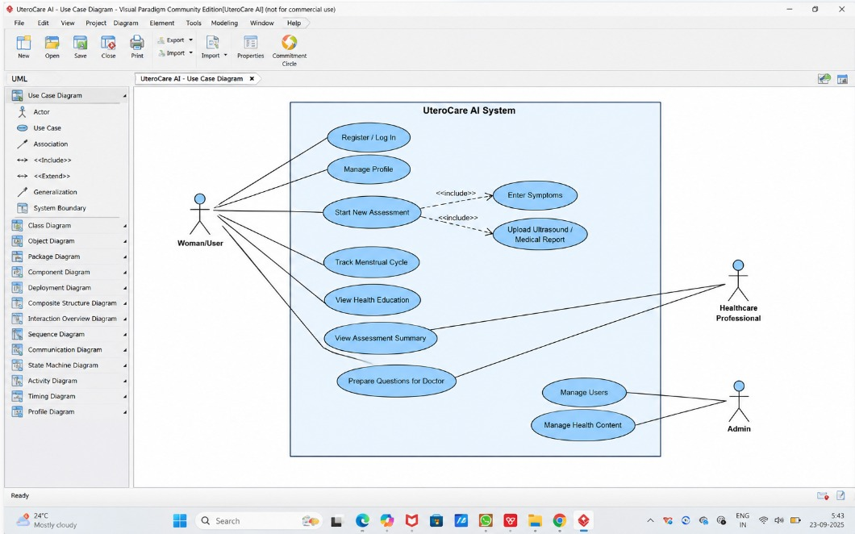
- Use case Diagram

2. Class Diagram
This diagram presents the main data and software classes in the proposed system. User represents an account; Assessment represents an assessment session; SymptomResponse and MenstrualEntry store symptom and cycle information; MedicalDocument represents an optional uploaded file; AssessmentResult stores the preliminary result and safety advice; ConditionInfo provides educational condition information; and ClinicianResource represents clinician-resource information. Associations show how a user creates assessments and how an assessment relates to its inputs and result.
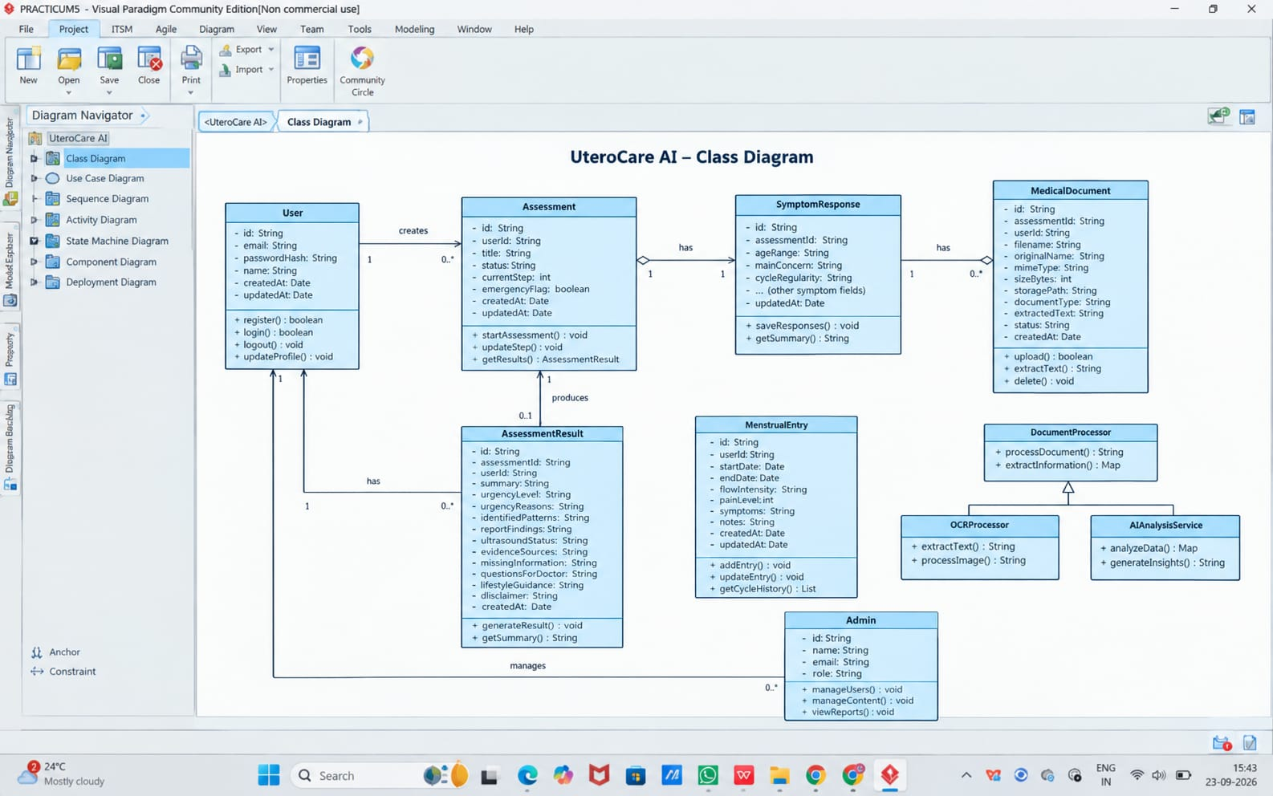
- Class Diagram

3. Sequence Diagram
This sequence diagram illustrates a typical scenario in which a patient submits symptoms and receives an assessment result. The Web UI sends requests to the API server, the server validates the session and input, data is stored in the database, and the assessment service generates a preliminary educational summary using relevant condition information. The UI then displays the result and safety guidance. The alternative path shows validation errors. Scan or report upload is optional, so symptom-only use remains possible.
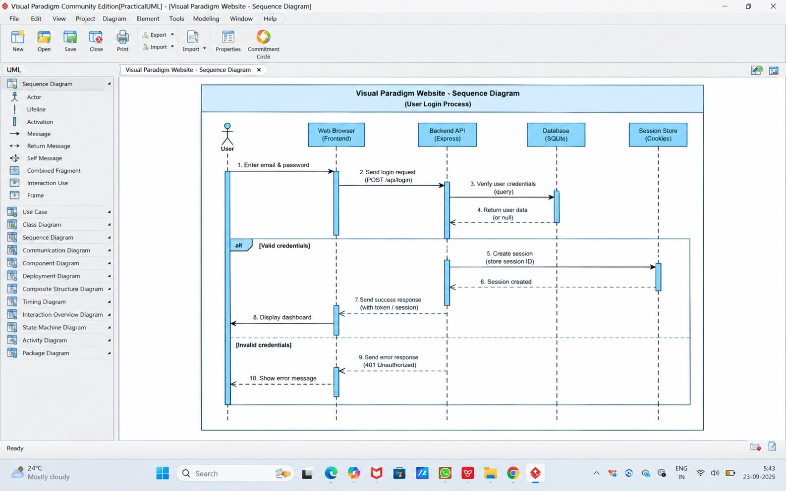
- Sequence Diagram

4. Activity Diagram
This activity diagram describes the end-to-end preliminary assessment workflow. It begins when the user opens the application and signs in. The user enters symptoms and menstrual-cycle details, then chooses whether to upload a scan or report. The workflow validates the inputs, handles invalid data or file uploads, generates and stores a preliminary summary, and displays limitations, safety guidance, and clinician resources. If urgent warning signs are reported, urgent-care guidance is displayed; otherwise, routine follow-up guidance is shown.
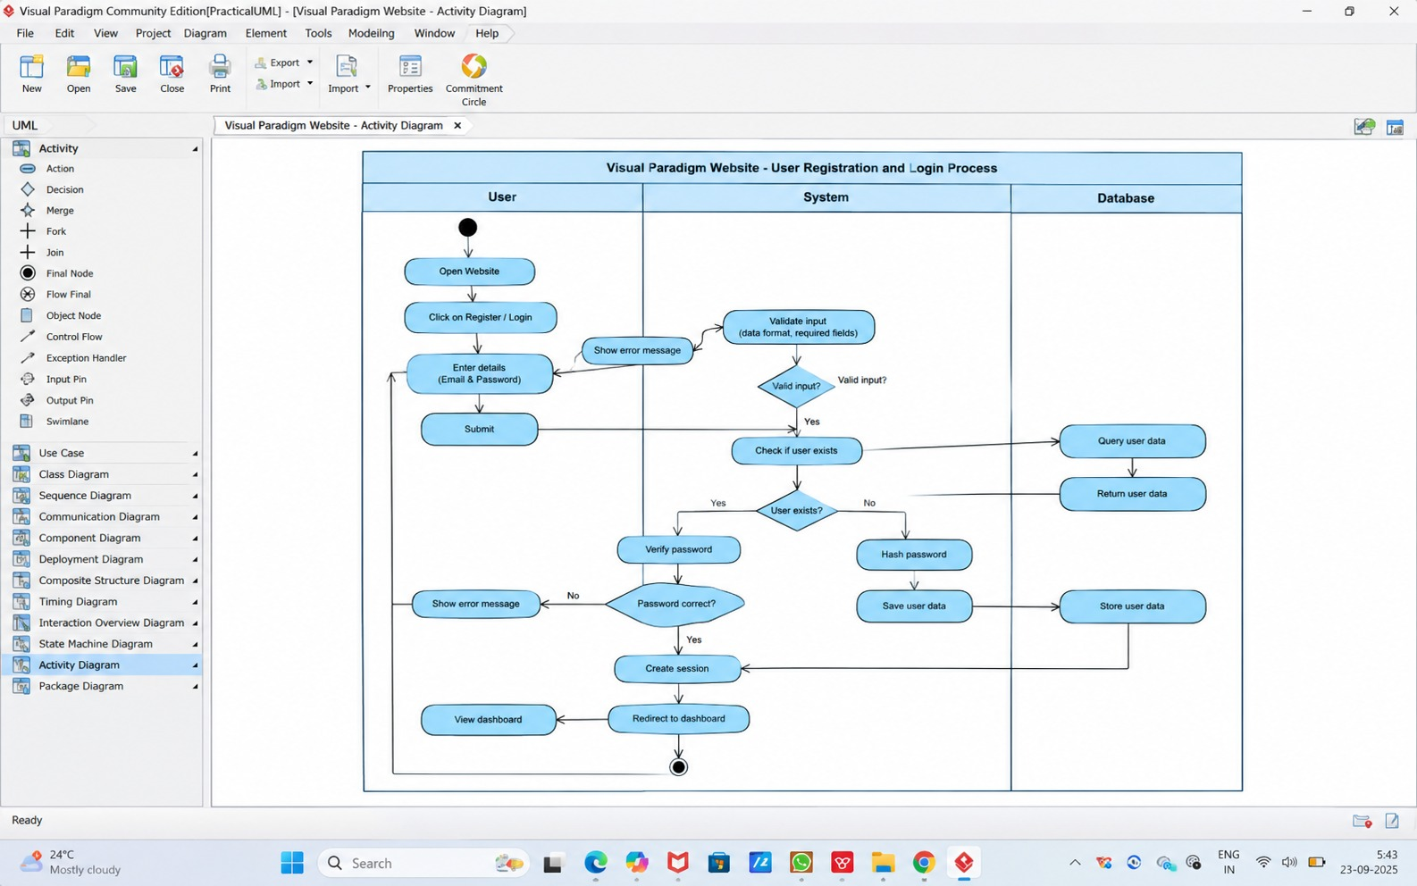
- Activity Diagram

5. State Machine Diagram
This state machine diagram focuses on the lifecycle of an Assessment object. An assessment begins in Draft, moves through Input Validation and the optional-evidence step, and then enters Processing. A preliminary result leads to Safety Review, which routes the assessment to urgent or routine guidance before it reaches Completed. The user may then close or save the assessment, moving it to Archived. Invalid inputs and processing failures may lead to correction or retry paths.
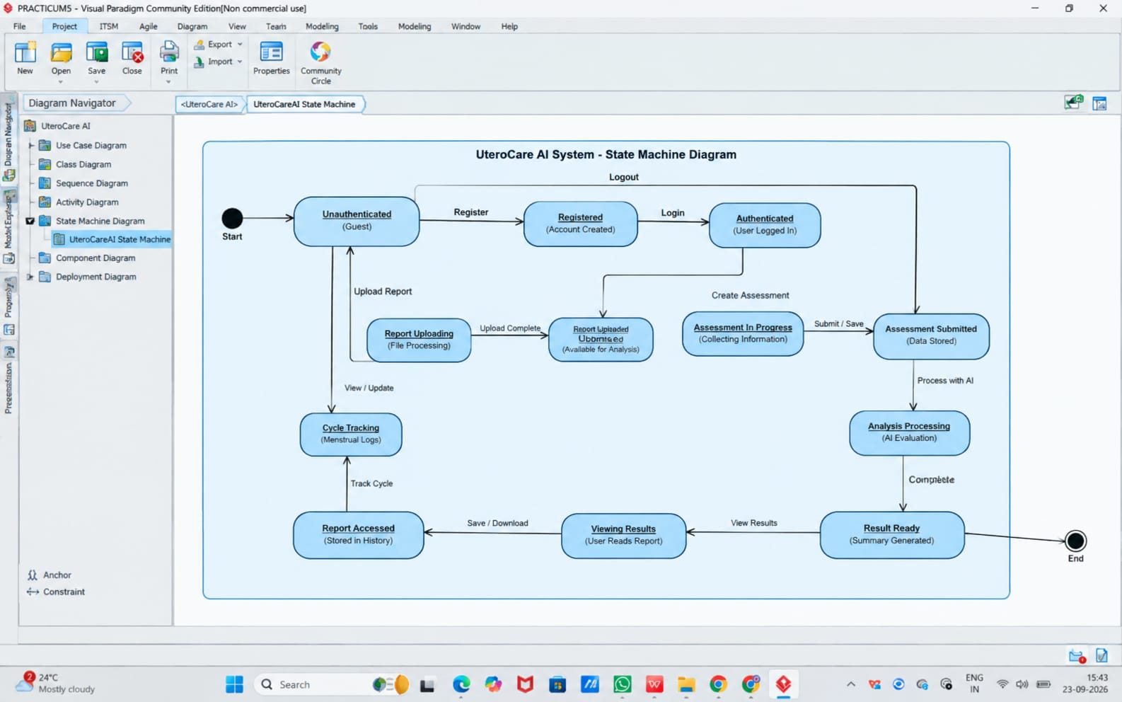
5.State Machine Diagram

